**Karan Arora**  **R.L. Institute M: 9416974837**

**Max Time : 1 hr** **Class = 12th Chemistry Max Marks : 25**

**Alcohol , Phenol , Ether – 1**

1. Compare boiling point of the following compounds : [ 1 ]

(a) CH3 – CH2 – OH (b) CH3 – CH2 – CH2 – OH (c) CH3 – (CH2)6 – CH2 – OH

1. Alcohols are comparatively more soluble in water than hydrocarbons of comparable molecular masses. Explain this fact. [ 2 ]
2. Give the equations of reactions for the preparations of phenol from cumene. [ 2 ]
3. Write chemical reaction for the preparations of phenol from chlorobenzene. [ 2 ]
4. You are given benzene, conc. H2SO4 and NaOH. Write the equations for the preparation of phenol using these reagents. [ 2 ]
5. Arrange : Water , Ethanol and phenol in increasing order of acidity and give reason for your answer. [ 2 ]
6. What is meant by Hydroboration-oxidation reaction? Illustrate it with an example. [ 3 ]
7. Give two reactions that show the acidic nature of phenol. Compare acidity of phenol with that of ethanol. [ 3 ]
8. Arrange the following compounds in decreasing order of acidity. [ 3 ]

(i) H2O , ROH , HC CH (ii) CH3OH , H2O, C6H5OH

(iii) 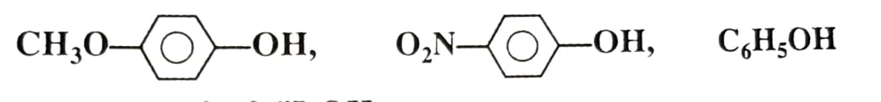

1. Write the IUPAC name of the following reactions : [ 1 x 5 = 5 ]

|  |  |  |  |  |
| --- | --- | --- | --- | --- |
| a) | b) | | c) | |
| d) | | e) | |